**Student Name: Tin Vu**

**CMSC 311 Computer Organization**

**LAB 4: Machine Language programming Using LC-3 Simulator**

**Instructor:** Dr. Cang Ye **Email:** [cye@vcu.edu](mailto:cye@vcu.edu) Office & Hours: E2240, TR 12-1 PM

**TA:** Lingqiu Jin **Email:** [jinl@mymail.vcu.edu](mailto:jinl@mymail.vcu.edu) Office & Hours: E2264, MW 2-3 PM

**Assignment**:

1. Write a machine level LC-3 program that finds the two's complement of a number stored in memory (location x301F) and stores the result back in memory (location x301E).

2. Write a machine level LC-3 program that searches for odd numbers in memory locations ranging from x3100 to x3110 (inclusively). Set R0 to be the number of the odd numbers that are found. Your solution should use an iterative construct like the examples in the lecture.

**Instructions:**

1. Your lab report is due no later than the date of the next class. Your lab report (in pdf format) should include your machine code and screenshots for each question. Submit both your lab report and source codes in separate files via blackboard. Please comment your code to make it easy to understand.

2. For screenshots, please include both your machine codes and solutions. The codes should start at address x3000 and all register information and the codes should be visible on the screenshot. The data that serves as the input to your program should be visible as well.

3. Grading policy: lab report 20%, source code 80%.

1. Write a machine level LC-3 program that finds the two's complement of a number stored in memory (location x301F) and stores the result back in memory (location x301E).

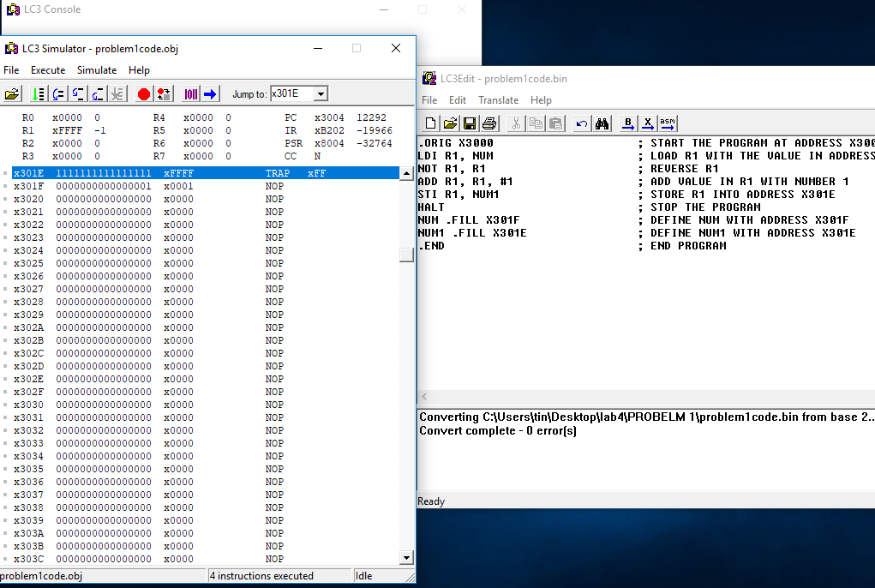

In this sample run! The picture above show the number (1) in address x301F that needed to be convert to 2 complement.

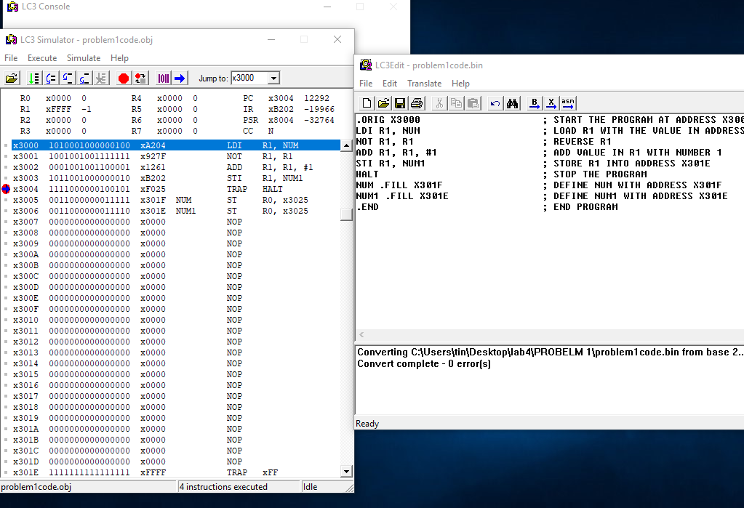

This picture show the sample run of the program with value of 1 in address location x301F

2. Write a machine level LC-3 program that searches for odd numbers in memory locations ranging from x3100 to x3110 (inclusively). Set R0 to be the number of the odd numbers that are found. Your solution should use an iterative construct like the examples in the lecture.

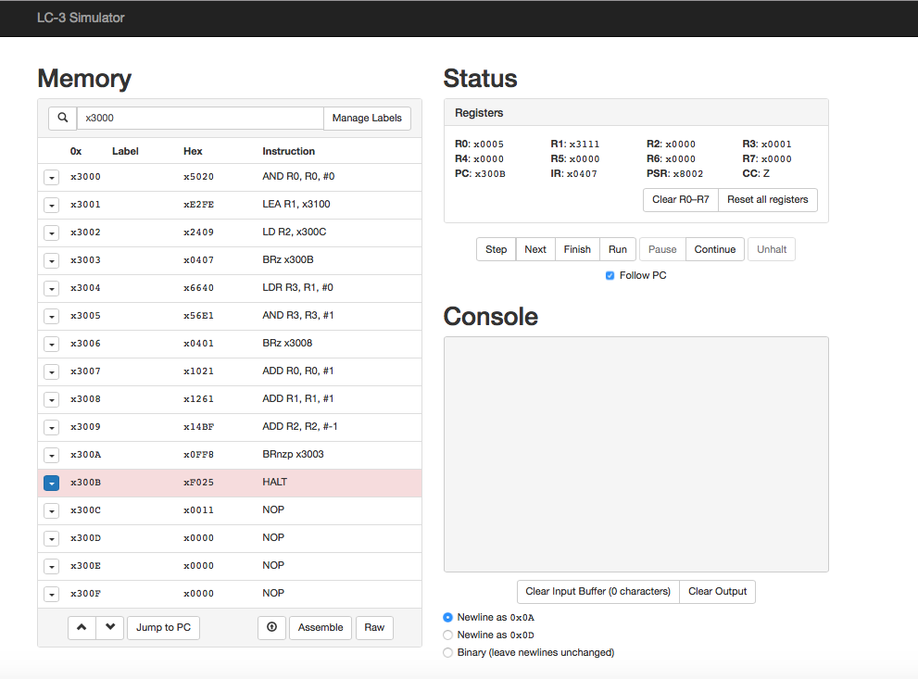

VirtualBox in my mac stopped working so I had to use the online simulator! Which means I only have the .obj file to turn in.

this sample run, I set the looping time in x300C to be 17 ( which is range from x3100 to x3110). And put values 1 to 10 into various addresses from x3100 to x3110.